Order BY
1) Display the lastname, firstname and salary of everyone in the candidate table. Order in ascending order based on lastname.
Use the column name to sort

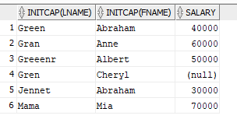

2) Display the lastname, firstname and salary of everyone in the candidate table. Order in Descending order based on the combination of lastname and first name
Do not use the column names but rather their position

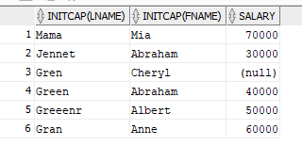
3) Display the lastname, firstname and salary * 2 (use alias double_salary) of everyone in the candidate table. Order in Descending order based on the alias
